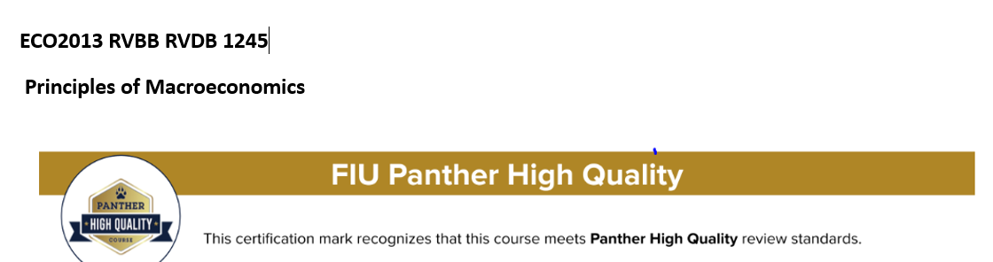

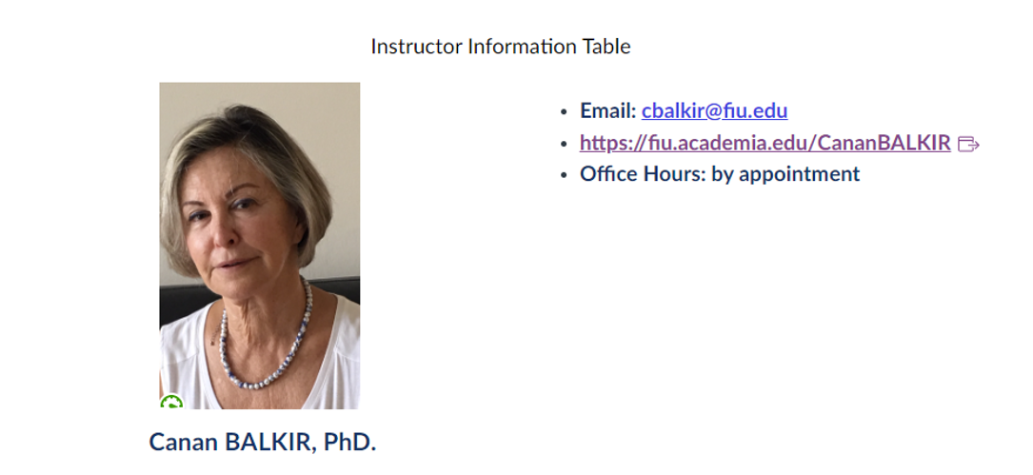
Course Description and Purpose
This is a fully Online Course and the knowledge gained in the course will make students better informed citizens and allow them to follow the debates over national economic policy. This course is also a foundation course that will prepare students to be successful in upper division finance, marketing, business administration, economics, government, and social work courses.
Topics included are the Economics Foundations and Models; Tradeoffs, Comparative Advantage, the Market System; Where Prices Come From; Interaction of Demand and Supply; Economic Efficiency, Government Price Setting, Taxes; GDP: Measuring Total Production and Income, Unemployment and Inflation; Economic Growth, the Financial System, and Business Cycles, Long-Run Economic Growth: Sources and Policies; Aggregate Expenditure and Output in the Short Run, Aggregate Demand and Aggregate Supply Analysis; Money, banks, and the Federal Reserve System; Monetary Policy, Fiscal Policy, Macroeconomics in an Open Economy and International Financial System.

Course Learning Outcomes
This course satisfies the University Core Curriculum for Social Sciences Group One (FIU required) as supported by the following learning outcomes for the course:
Upon completing this course, students will be able to:
- Explain the basic premises and tools of economic thinking.
- Use economic thinking to explain choice in a world of scarcity.
- Analyze how buyers and sellers interact in a free and competitive market to determine prices and quantities of goods.
- Evaluate applications of supply and demand, including price floors, price ceilings, and taxes.
- Calculate GDP and use it to evaluate economic performance.
- Evaluate macroeconomic performance using indicators that include unemployment and inflation.
- Describe and analyze the sources of economic growth.
- Identify that economic growth is a relatively recent phenomenon, and identify key institutional factors and policies that contribute to economic growth.
- Explain Keynesian economics using the Income-Expenditure Model.
- Utilize and construct the aggregate demand-aggregate supply model to analyze the economy.
- Explain the role of money and banking in an economy.
- Explain and analyze monetary policy and the role of the Federal Reserve.
- Identify what government budgets consist of and describe the uses and implications of fiscal policy.
- Analyze the benefits and costs of international trade, globalization, and international financial system
- Examine exchange rates and the way they influence international trade.
- Evaluate the net gains arising from international trade.
Policies
Before starting this course, please review the following pages:
- Policies
- Netiquette
- Technical Requirements and Skills
- Accessibility and Accommodation
- Panthers Care & Counseling and Psychological Services (CAPS)
- Academic Misconduct Statement
- Inclusivity Statement

Religious Observance
Accommodations will be made for students who wish to observe their religious holidays. Students should make their requests known at the beginning of the semester – during the first week of classes.

Course Prerequisites
There are no prerequisites for this course.

Proctored Exam Policy
This course does not require proctored exams.

Textbook and Course Materials
Access to MyLab and Mastering is REQUIRED for this course. An e-version of the textbook is already included in the package when you purchase the access to the content of this course on My Lab and Mastering, so purchasing a physical copy of the textbook is not necessary; however, should you still prefer, you could purchase/rent the physical version of this textbook separately.
There are two options for the purchase of the access code (prices may vary): 1) You can buy access through FIU bookstore or 2) You can register through Canvas course homepage.
Regardless of how the access code is purchased, students have to register on MyLab and Mastering through Canvas course homepage. MyLab and Mastering offers free, temporary access for a trial period of about 14 days. All the coursework accomplished during this trial period will be preserved when the registration is renewed. It is a student's sole responsibility to promptly renew their temporary registration to avoid the disruption of their coursework progress.

Registering for MyLab Economics Access
I recommend you always enter your MyLab Economics course through Canvas.
Online access to the e-text and MyLab Economics can be accessed by clicking on the MyLab and Mastering link in Canvas. If you need additional guidance, consult the support site, especially the system requirements which list recommended browsers.
If you have problems registering, purchasing, or logging in, please contact Customer Support.
Pearson Support is available to assist you on the phone, through email, or with online chat.
- Email services are available 24 hours a day, 7 days a week.
- Chat services are available Monday through Thursday (8am - 12 midnight) and Friday (8am - 10pm).
- For the best experience, check the system requirements for your product at https://www.pearsonmylabandmastering.com/system-requirements/
- https://help.pearsoncmg.com/integration/cg/canvas/student/en/content/get_started.htm

Expectations of this Course
This is an online course, which means most (if not all) of the course work will be conducted online. Expectations for performance in an online course are the same for a traditional course. In fact, online courses require a degree of self-motivation, self-discipline, and technology skills which can make these courses more demanding for some students.
Students are expected to:
- review the getting started page located in the course modules;
- introduce yourself to the class during the first week by posting a self-introduction in the appropriate Discussion Forum;
- take the practice quiz to ensure that your computer is compatible with the learning management system, Canvas;
- interact online with instructor and peers;
- review and follow the course calendar and weekly outlines;
- log in to the course 3 times per week;
- respond to emails within 2 days;
- submit assignments by the corresponding deadline.
- The instructor will:
- log in to the course 3 times per week;
- respond to emails within 48 business hours;
- grade assignments within 4 days of the assignment deadline.

Economics Tutoring Center
The Economics Department has provided a classroom designed to assist students enrolled in various economics courses. The Tutoring Center is located at MMC in VH 136, and is open Monday-Friday from 9:00 AM – 5:00 PM. Economics Ph.D. students are available during these times to help with any questions you may have. Additional information available at FIU Economics Tutoring Center.

Course Communication
Communication in this course will take place via the Canvas Inbox. Check out the Canvas Guide to learn how to communicate with your instructor and peers using Announcements, Discussions, and the Inbox. The lecturer/ TA I will respond to all correspondences within 48 business hours.
Students will use Open Forum under Discussions to discuss homework, exam preparation, and other content-related questions or comments with their peers, instructor, and TA.

Zoom Video Conference
Zoom is a video conference tool that you can use to interact with your professor and fellow students by sharing screens, chatting, broadcasting live video/audio, and taking part in other interactive online activities. We will be utilizing this tool to conduct virtual office hours.
Zoom meetings can be accessed via the Zoom link in the course navigation menu. Once you click on the Zoom link, it will route you to join the meeting for the respective class session. You will also be able to view upcoming meetings, previous meetings that you have already joined, and meeting recordings. Before joining an actual class session:
- Reference the Zoom Student Tutorials to learn about the tool, how to access your meeting room, and share your screen.
- Access the Zoom Test Meeting Room to test out the software before joining an actual session.
If you encounter any technical difficulties, please contact the FIU Canvas Help Team Please ensure you contact support immediately upon the issue occurring.

Course Structure
There are a variety of resources available through MyLab Economics that should be utilized in order to achieve the highest grades possible for the course. The progression of learning resources that students should follow is listed below:
- Textbook Reading
- Chapter Videos & Animations
- Chapter PowerPoint Presentation
- Chapter Solved Problems
- Chapter Activities
- Chapter Study Plan
- Chapter Dynamic Study Module

Assignments
1. Introduce Yourself (5% of overall grade)
During the first week of class, every student should create his/her own student bio, not longer than 300 words. You are encouraged to include the following in your bio: name, status freshman /sophomore/ junior/senior), your reason for taking the course, your expectation of the course. Please only give FIU Directory Information and read your right to limit disclosure of some personally identifiable information, protected by FERPA. You can attach your photo, recommended but not required. 5% of the total grade.

2. Homeworks (45% of overall grade)
Homework consists of fifty (50) questions from each respective chapter. Every chapter has a Homework assigned and must be completed by 11:59 PM of the due date. HomeWorks are open-book and open-note. Students have three (3) attempts to complete the homework assignment, in which the highest score will count as the recorded grade. Students will have an unlimited amount of time to answer all the questions once the assignment is opened in MyLab Economics. Please be sure to save and submit the assignment once you have completed it.
Late homework assignments will be graded with a late submission penalty of 5% daily. Deadlines are strictly enforced. Please be mindful of these dates, as they will not be changed, barring any extenuating circumstances.
The only time the due dates will be extended is if there are any technical difficulties on MyLab Economics’ system. If there is, please provide screenshot of the error and record as much evidence as you can, as well as sending an e-mail explaining the situation to Pearson technical support and me. If the fault lies with Pearson MyLab Economics, I will extend the due date. If you do not follow these steps, then no extension will be given.
Students are responsible for reading all the announcements and important date changes. You should check your FIU e-mail and Course Announcements on Canvas.

3. Exams (50% of overall grade)
There are three (3) exams in total. You are required to take all the exams at the scheduled time unless you have a university-sanctioned schedule conflict. If you think you have a schedule conflict, please notify the instructor at least one week before the exam. All exams will be taken online through MyLab Economics.
The detailed information for exams is given as follows:
- Partial Exam 1 (Chapters 1, 2, 3, 4)
- Partial Exam 2 (Chapters 8, 9, 10, 13)
- Partial Exam 3 (Chapters 14, 15, 16,7)

Important Notes about Exams: Exams will be available for completion and submission on the noted dates. Each exam consists of fifty (50) questions from the noted chapters. Exams must be completed by the due date and time, otherwise a score of “0” will be applied. Students have one (1) attempt to complete each exam, in which the score will count as the recorded grade. Students will have 120 minutes (2 hours) to answer all of the questions once the exam is opened in MyLab Economics. Once opened, the exam must be completed in one sitting. The exam will automatically close on the due date and time, so please ensure you begin the exam at least 120 minutes before the deadline. Be sure to save and submit the exam once you have completed it.
Since exams are online, they are open-book and open-note. However, a full understanding of the material will be needed to answer all questions.
The assignments (exams and homeworks) must be completed through Pearson's MyLab Economics.

Missing Exam Policy
If you end up not taking an exam due to technical or computer issues, medical reasons, family emergencies, etc., provided proper documentation, your missing exam grade will be replaced by an average of your other two exams. Any additional missing exams will receive a score of “0”. Make-up exams will not be given. This ensures equitable opportunities for all students to be assessed through the course’s exams.

Grade Distribution Table
Course Requirements | Number of Items | Points for Each | Total Points Available | Weight
Introduce Yourself | 1 | 5 | 5 | 5%
Exams | 3 | 50 | 150 | 50%
Chapter Homework | 12 | 50 | 600 | 45%
Total | 16 | -- | 755 | 100%

FIU standard scale is used to determine your final letter grade, although I do reserve the right to be more generous if appropriate.
Incomplete Grade (IN) An incomplete grade is a temporary symbol given at the discretion of the instructor for work not completed because of serious interruption not caused by the student’s own negligence. Incomplete grades may be given in this Course only in the following circumstances:
- The student's work to date is passing;
- Participation has been satisfactory through at least 60% of the term.
- Please see FIU’s Policy for Assigning an Incomplete “I” Grade.
- If you have any questions or concerns about your grade, please contact the instructor immediately. Please be proactive about your grades, and do not wait until the last minute.

Disability Clause
Students by law, have the right to receive needed accommodations if their disabilities make it difficult to perform academic tasks in the usual way or in the allotted time frame. In order to receive accommodation. Students with must register with Disability Resource Center:
University Park Campus, GC 190
Voice: (305) 348-3532
TTY: (305) 348-3852
Fax: (305) 348-3850
Email: drcupgl@fiu.ed

Handshake is the school’s official job/internship portal. Thousands of employers are hiring students on Handshake. Once you fill in your career interests, you’ll get personalized recommendations for jobs and events and direct outreach from employers interested in students like you—80% of students with a complete Handshake profile get messaged by employers! Activate your account at https://fiu.joinhandshake.com/login

Disclaimer: The syllabus is a statement of intent and serves as an implicit agreement between the instructor and the student. Every effort will be made to avoid changing the course schedule, but the possibility exists that unforeseen events will make syllabus changes necessary. Please remember to check your email and the course site often.

